STARTED

Hello user!

We, at Motilal Oswal Financial Services Ltd (MOFSL), are glad to be by your side in your trading/investing journey.

In the following article(s), we will share with you each and every detail about how to open account. Simple, transparent, reliable - it is the most user- oriented online platform available to Indian traders today.

Let us now start this learning journey by describing how to set up and operate your MOFSL account.

**How to Open an Motilal Oswal Financial Services Ltd. Trading and Demat Account**

1. **Offline:** Visit nearest branch with the requisite documents to open a Trading and Demat account and MOFSL Branch / AP staff will further assist in onboarding journey with MOFSL. Document checklist attached



1. **Online:** Opening a demat and trading account with the MOFSL through web is a simple process that barely takes ﬁve minutes.

The following are the steps that you need to follow in order to activate your MOFSL demat and trading account online:

**Visit our online web site** [**https://www.motilaloswal.com/**](https://www.motilaloswal.com/)

**Step 1: Basic details**

1. Enter your Full Name as per Aadhaar card
2. Enter your mobile number (for all future communications). The mobile number must be unique, i.e. there should be no prior MOFSL accounts with that number.
3. An OTP will thereafter be sent to that number for conﬁrmation.
4. Once you are done, click on ‘**Proceed**’.

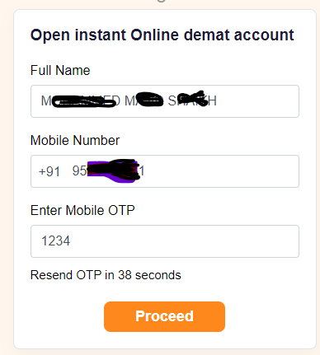

1. Once the OTP is conﬁrmed, you can then enter the **email ID manually or you can use if your already login** that you want to register with us.
2. In case you enter your email ID manually, an OTP will be sent to the email address which you have to enter within the next 60 seconds, in order to conﬁrm your email ID.
3. Once you are done, click on ‘**Proceed**’.

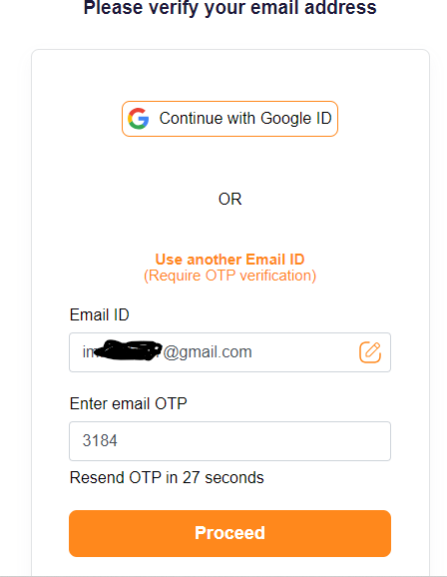

# Step 2: Complete Your KYC Journey

At this point, your KYC (Know Your Customer) process begins. It is mandatory to verify your KYC for trading in equities. Data will be automatically pulled from KRA website, in case of existing account with another broker. Else need to enter address, father’s/spouse name and other personal details.

1. Enter your PAN number. The PAN number must be unique, i.e. there should be no prior MOFSL accounts with that PAN number and your name will be display as per income tax record.
2. Enter Date of birth
3. Once you are done, click on ‘**Proceed**’

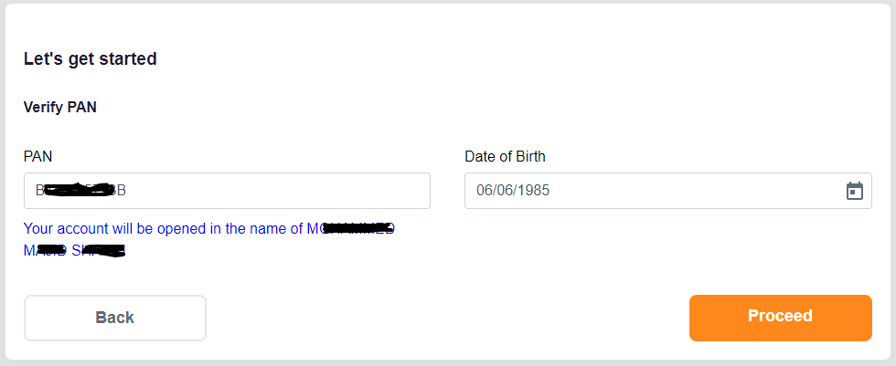

# Step 3: Fill in Your Bank Account Details

You must link at least one bank account with your trading account. This helps in quick fund transfers. In order to enter your bank account details, follow the below steps:

1. Enter your Bank account number. The PAN number must be unique,

i.e. there should be no prior MOFSL accounts with that PAN number and your name will be display as per income tax record.

1. Enter Date of birth
2. Once you are done, click on ‘**Proceed**’

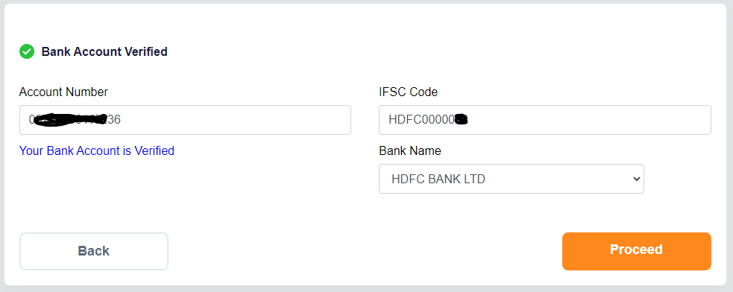

# Step 4: Enter Your Personal Details

In order to take the below steps, do the following:

1. Select PEP confirmation.
2. Select your investment experience.
3. Select your income category.
4. Select DIS option.
5. Select your Qualification.
6. Select your employment (Occupation) type.

# Adding nominees

At this point, you may choose to add a nominee to your demat account by clicking on “**Add Nominee**”. Clicking it will take you to the relevant page where you will be asked to ﬁll in -

* 1. Name of the nominee.
  2. Their PAN number.
  3. Their Date of Birth.
  4. Percentage - A single demat account holder can add up to 3 nominees. Therefore, in this section, the account holder has to specify what percentage of their holdings the particular nominee is going to be entitled to. The total percentage held by all the nominees in the list together has to be 100%.
  5. Their relationship with you, i.e. the demat account holder.
  6. Select their gender.
  7. Update their address. You may select same as account holder address if same.
  8. Once you are done, click on ‘**Proceed**’

You can also add a nominee later through the MOFSL web login.

1. Read and tick on terms and condition confirmation check box. If terms and conditions stated in Online account opening is not acceptable to client, then client can follow offline account opening process.
2. NRI and NON Individual account are activated offline. For offline Account opening please contact 022-40508000.

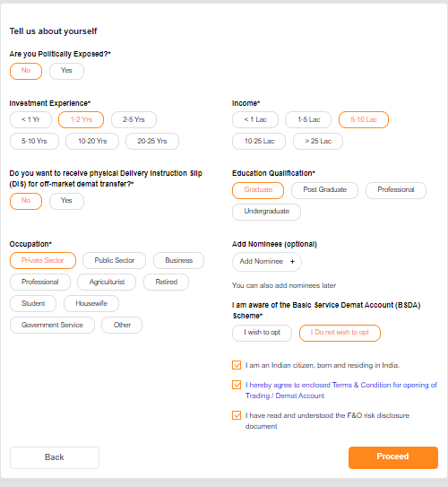

# Step 5: Add funds

You may also add the funds for trading at the time of account opening or you may skip and add the funds after complete activation. You can also view your brokerage charges by clicking on view brokerage charges.

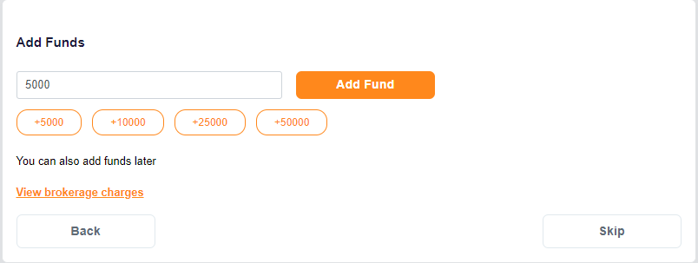

# Step 6: Upload your documents

1. **Upload your signature**

You will have to upload a signature. Click a picture of your signature on a white paper and upload it.

# Aadhaar confirmation.

You can click on **Yes** if your mobile number linked with Aadhaar and No if your mobile number not linked with Aadhaar.

# Upload Your Live Photo / Selfie

Place your face within the circle and click the camera icon to take the selﬁe.

# Trade in F&O Activate (Optional)

Choose any one income proof document out of -

* 1. Bank Statement (Latest 6 months)
  2. Form 16 (Latest ﬁnancial year)
  3. Salary Slip (Latest 2 month)
  4. ITR (Latest ﬁnancial year)

**Note:** Document types accepted include .pdf, .jpeg, .jpg & .png ﬁles of upto 5MB maximum. In case the ﬁle is password protected, provide the password when prompted.

***If you do not activate F&O at this point you can still activate it later.***

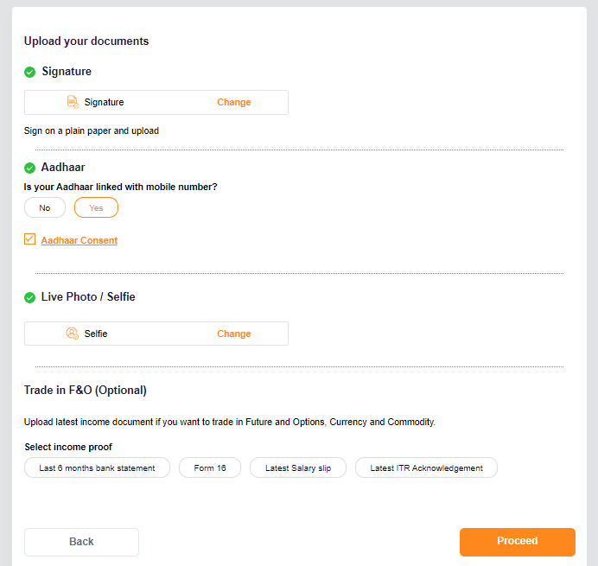

# Step 7: Complete Your E-Signature

At this point, if you have a Digilocker, you can proceed to perform an

e- Signature. This will take you to the NSDL website, where you have to authorise the NSDL e-Gov to use your Aadhaar/Virtual ID for the e-sign. Thereafter, enter the Aadhaar ID and click on “Send OTP”.

You can also generate a virtual ID during this transaction and use it in place of Aadhaar. Once this process is over, MOFSL will have received all requisite documents.

You have to complete the two e-signatures 1 for KRA (Kyc Registration

Agency) and 2 for final KYC (Know your customer) pdf.

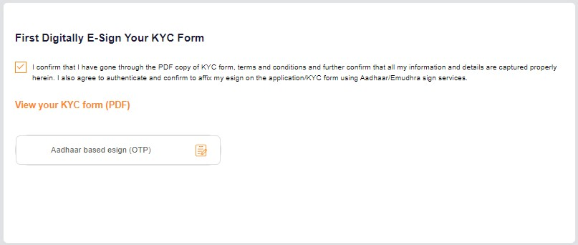

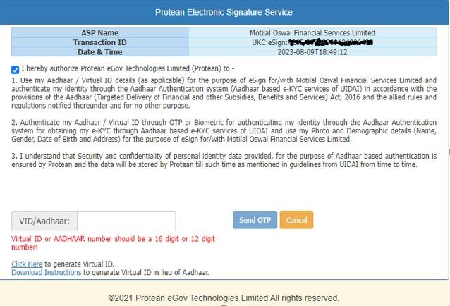

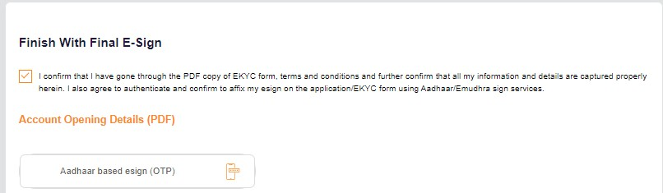

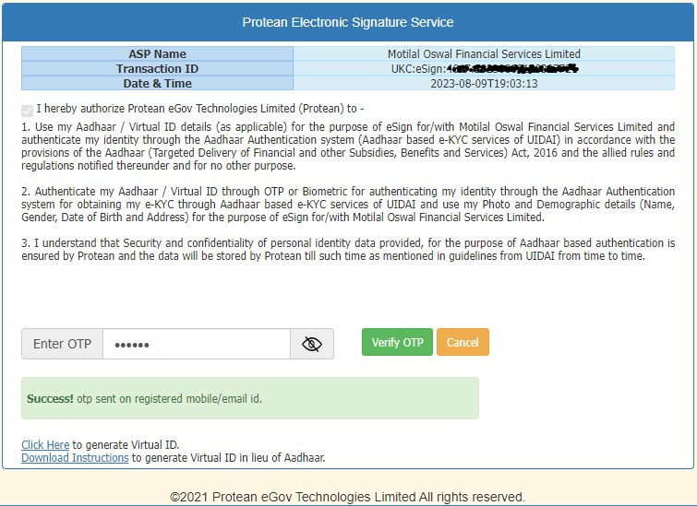

After complete the account opening process, you will get the confirmation message on screen. “Congratulations” Your Motilal Oswal Demat account has been created and your User ID is

